LMPC general comment on this section (no further comments)
Langton Matravers Parish Council is very concerned that development of new housing is apparently being considered in this area without proper appreciation of the already-overloaded road system which moves traffic out of the peninsula and across the area, For example, the A352 which connects Wool with the BCP area is already inadequate at peak times every day: more housing will exacerbate the problem making it hard for people to get to work and move efficiently about the region..

Introduction
SED1: The South East Dorset Green Belt

Development proposals in the Green Belt will be determined in accordance with national planning policy.
In order to deliver sustainable patterns of development, the council has concluded that there are exceptional circumstances to make changes to Green Belt boundaries (as shown on the policies map and detailed in the corresponding settlement chapters) aroundthe following settlements:
- Corfe Mullen;
- Lytchett Matravers;
- Ferndown/West Parley;
- Sturminster Marshall;
- Verwood;
- Upton;
- Wareham;
- West Moors; and
- Wimborne Minster/Colehill
Q: Green Belt
Do you agree that there is a need to amend the green belt to enable development?

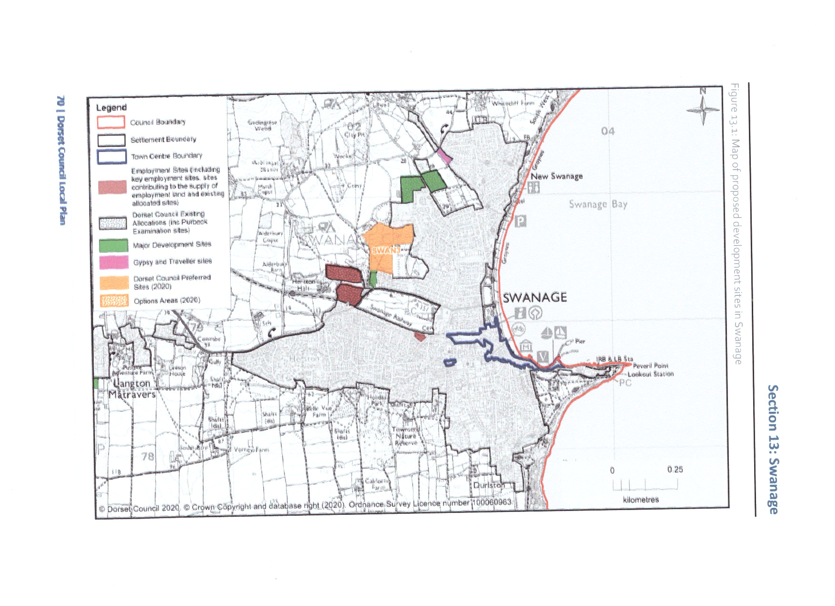
SWANAGE

SWAN1: Swanage town centre
- The boundary of Swanage Town Centre is shown on the policies map along with the primary and secondary retail frontages.
- The preferred locations for additional town centre uses to serve Swanage, as shown on the policies map, are:
- between the railway station and Kings Road West;
- the former depot site at the junction of Court Road and Kings Road West;
- the Post Office sorting officeon Kings Road East.
- Development of these sites must respect the character of the conservation area and other heritage assets, and be integrated into the existing town centre through enhancements to the public realm.

SWAN2: Northbrook Road East
- Land to the east of Northbrook Road, as shown on the policies map, is allocated for residential development.
- The development should:
- be designed to offer a comprehensive scheme that maximises the benefits of development whilst respecting the sensitivities of the site in the landscape;
- deliver a SANG that makes the most of the opportunities to connect with the SANG provided to the west of Northbrook Road;
- deliver enhancements to cycle and pedestrian routes to and from the site and into the town centre.

SWAN3: Land to the west of Prospect Allotments
- Land to the west of Prospect Allotments, as shown on the policies map, is proposed for residential development including the provision of a care facility
- Development of the site should be of high-quality design and incorporate significant tree planting to soften the edge of the town within the AONB landscape. Planting within the site should further break up the built form
- The northern part of the site should deliver an appropriately sized SANG to minimise impact on nearby heathlands and to soften the development in views from the Purbeck Ridge
- Development should make best use of existing footpath connections to enable convenient, safe and attractive pedestrian and cycle routes into the town centre and to nearby facilities.
Q: Land to the west of Prospect Allotments1: Do you agree with the allocation of this site?
2: Is there anything not cov
ered within the policy that should be considered in relation to the site?
3: Are there any community infrastructure needs within the area that should be considered?

SWAN4: Swanage townscape character and development
- In order to conserve and enhance the existing townscape character of Swanage, new development should take account of the Swanage Townscape Character Assessment (2012).
WAREHAM

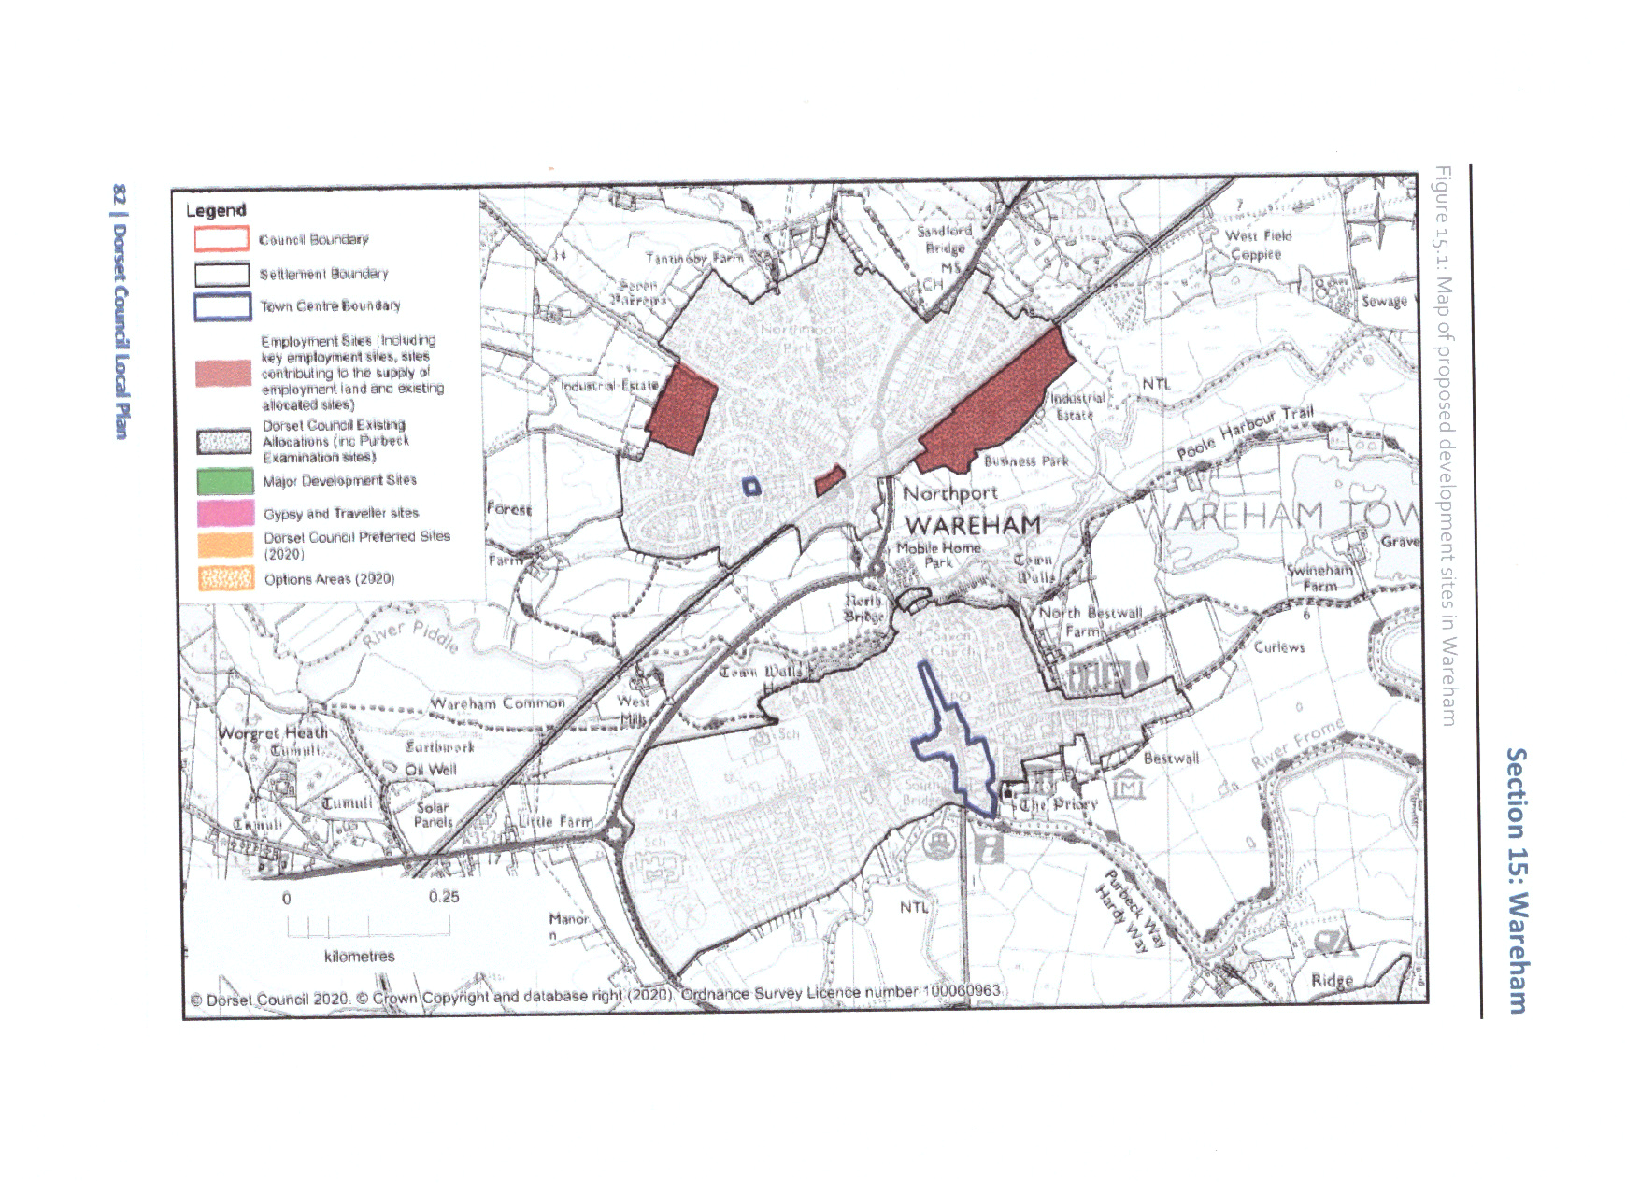

WAR1: Wareham town centre strategy
Development within Wareham town centre boundary, as shown on the policies map,will be supported if:•the proposed use and associated works would not harm the historic interest and character of the conservation area and listed buildings; and•the proposed use and any associated physical alterations would maintain an active and publicly-accessible ground floor use that enlivens the streetscene.
Q: Wareham town centre strategy
1: Do you agree with the suggested approach and what it is trying to achieve?
2: Do you agree with the suggested wording?3:
How could the paragraph / policy / section / chapter be amended to reflect your concerns?

WOOL

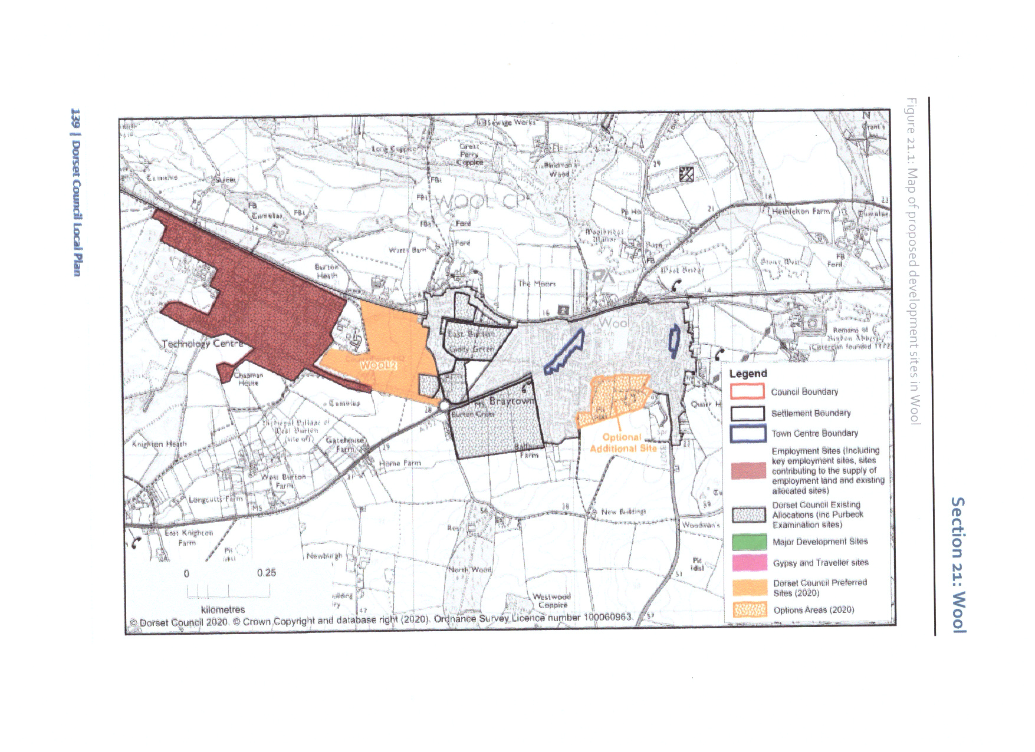

WOOL1: New housing at Wool
- Land at Wool as shown on the policies map, is allocated for residential development includingcommunity facilities and supporting infrastructure.
- Housing development on all the allocated sites in Wool will be expected to:•
- provide around 350m2 of convenience retail floorspace;•
- provide contributions towards improvements at the D’Urberville Hall community facility or explore opportunities to provide a community hub;•
- improveaccessibility between the sites and nearby services and facilities by forming or improving defined walking and cycling routes;•
- contribute towards improvements to the travel interchange at Wool Railway Station to include additional car parking, secure cycle storage, and electric vehicle charging points;•
- include mitigation measures for any safety risks at the level crossing, as proposed through a traffic statement or safety assessment, satisfying the requirements of Network Rail and the highways authority;•
- include details in a traffic statement or assessment of improvements to the local road network (C6) and a program to reduce volumes of traffic on the A351 by encouraging use of the C6 road;
- •provide financial contributions for education provision;•
- conserve, and where appropriate look for opportunities to enhance, the significanceof heritage assets including scheduled monuments, listed buildings on neighbouring land and non-designated heritageassets within development sites; and
- provide and manage in perpetuity a SANG totalling 32.7 hectares to avoid the adverse effects from the new homes on European sites. The applicant will provide details for phased implementation of development and access to the SANG, along with details of site access management and monitoring to demonstrate that adverse effects can be avoided over the lifetime of the development. Where features with significant existing biodiversity value have been identified within the SANG (e.g. trees with bat roost potential and badger setts), detailed design and appropriate management (e.g. routing of footpaths and retention of existing broadleaved trees) must be agreed with the council and delivered by the landowner to ensure that these features are protected and enhanced
Land to the west of Chalk Pit Lane and Oakdene Road
- Development on this part of the site will be expected to:•
- provide care accommodation designed in consultation with local health and social care providers to meetthe changing needs of older and disabled people in Purbeck. The scheme should aim to provide around 65 extra-care units,and10% of its overall housing requirement as supported housing for the elderly or age-specific housing;•
- avoid, and where necessary mitigate or remediate, the effects of possible contamination and avoid any development within a buffer around a pipeline located on the western boundary; and•
- include an undeveloped buffer between the southern edge of the site and the scheduled monument and explore opportunities to enhance the scheduled monument's significance.
Land to the north-east of Burton Cross Roundabout
- Development on this part of the site will be expected to:•
- avoid, and where necessary mitigate or remediate, the effects of noise from the adjoining railway line;•
- explore opportunities to provide informal/formal open space on the land;•
- conserve the setting of nearby listed buildings; and•
- explore opportunities to deliver a new footpath link to Burton Road.
Land to the north-west of Burton Cross Roundabout
- Development on this part of the site will be expected to:•
- conservethe setting of nearby listed buildings.
Land to the north of the railway line
- Development on this part of the site will be expected to:•
- avoid, and where necessary mitigate or remediate, the effects of noise from the adjoining railway line;
- conserve the setting of nearby listed buildings; and•e
- xplore opportunities to deliver a new footpath link through the land between Sandhills Crescent and East Burton Road

WOOL2: Land to the west of East Burton
- Land to the west of East Burton, as shown on the policies map, is allocated for residential development as an extension to the existing area proposed for development
- .Development on this site will be expected to:•
- avoid, and where necessary mitigate or remediate, the effects of noise from the adjoining railway line;•
- explore opportunities to provide informal/formal open space on the land;•
- explore opportunities to deliver a new footpath and cycleway links to Dorchester Road and Burton Road;•
- retain and enhance existing hedgerows and treed areas; and•
- include multifunctional, connected green infrastructure and sustainable links to the wider area.
Q: Land to the west of East Burton?
1: Do you agree with the allocation of this site?
2: Is there anything not covered within the policy that should be considered in relation to the site?
3: Are there any community infrastructure needs within the area that should be considered?

Agreed by resolution of the Council 11.5.2021

