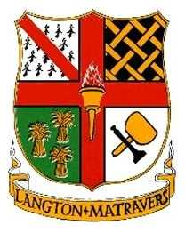

Langton Matravers Parish Council
1A High Street Langton Matravers Dorset BH19 3EU

His Majesty the King
Buckingham Palace
London
SW1A 1AA

9th September 2022

Condolences

Sir,

Upon the death of Your Majesty’s Mother, Her Royal Highness Queen Eliabeth, it is with great sadness that I on behalf of the parishioners and Councillors of Langton Matravers send condolences to Your Majesty and Your Majesty’s family.

Her Royal Highness will be missed by us all not just for Her service and sense of duty but also for Her smile and generosity of spirit.

Parishioners and Councillors will individually be signing the Parish Book of Condolences, which will ultimately be consolidated with other such books in the Unitary Authority of Dorset and then held in the local archive.

I have the honour to be, Sir, Your humble and obedient servant.

William Knight
Chair of Langton Matravers Parish Council

