Exclusive right of burial.
When you buy a grave at Crack Lane Cemetery, Langton Matravers, what you are buying is the Exclusive Right of Burial for a specific period of 99 years, You are not buying the grave freehold. No burial may take place in the grave and no memorial may be placed on the grave without the written permission of the grave owner during the period of the Exclusive Rights. A fee is payable for the digging and preparation of a grave at the time of burial and a fee is also payable for the installation of a memorial. The Exclusive Rights must not exceed 99 years in total.
Ownership of the Exclusive Right of Burial is therefore a very important matter. Ownership can be transferred either during the owner’s lifetime or after their death. The procedure for transferring the ownership is detailed below. The Council’s records contain the details of the registered grave owners. However, it is important that the grave owners keep safe their Deed of Grant. The Council issues this Deed of Grant when the grave is first purchased and should be produced for each burial. Possession of the Deed does not in its self-signify ownership of the Exclusive Rights.

Transfer of grave ownership.
The grave owner can assign the Exclusive Rights of Burial, during their lifetime, to another individual on completion of an Assignment Form.
The owner can surrender the Exclusive Rights of Burial if the grave has not been used for burial, on completion of a Surrender Form. The surrender value being the original purchase price as specified on the Deed of Grant less an appropriate administrative cost.
The procedure for establishing grave ownership when the original owner has died depends upon whether there is a will.

Deceased left a valid will.
If the deceased grave owner has made a valid will and left an estate of sufficient value to require the Grant of Probate to executors, ownership of the grave can be transferred to the executor. The applicant must produce a sealed copy of the Grant of Probate and complete the Transfer-Grant of Probate Form. If the estate is not of sufficient value, ownership may be transferred to the executor named in the will by Statutory Declaration and the production of the will. It is then the executor’s responsibility to identify the correct person for the transfer of ownership and assent the transfer by completing an assent form.

Grant letters of administration have been obtained.
If there is no will, or the will is not valid, and the estate is of sufficient value as to require a Grant of Letters of Administration, ownership of the grave can be transferred to the personal representative of the deceased. The applicant must produce a sealed copy of the Grant of Letters of Administration Form. It is then the applicant’s responsibility to identify the correct person for transfer of ownership and assent the transfer by completing an Assent Form.

Family disputes.
Where a family dispute results in a stalemate and relevant consents are withheld, the ownership cannot be transferred. The various next of kin reaching an agreement between them, possibly through the agency of solicitors, can only resolve this.

Deceased dies intestate.
If there are no Executors or Letters of Administration have not been granted, the rules of intestacy apply as laid down in the Administration of Estate Act 1925. The applicant for transfer of ownership should complete a Statutory Declaration. Statutory Declarations are legal documents produced by this office and must be signed in the presence of a Magistrate or Commissioner for Oaths.
The Statutory Declaration should clearly set out the facts regarding the original purchase of the Exclusive Rights of Burial, the death of the registered owner, intestate or otherwise and the relationship of the applicant to the registered owner. The original Deed of Grant and a certified copy of the owner’s death certificate should accompany the Declaration. Where the Deed has been lost, suitable wording should be incorporated within the declaration to the effect. It is essential that the written agreement of all the 3 next of kin of the deceased owner to the transfer of ownership should also be obtained and attached to the Declaration. The following are examples of many of the possible circumstances:

Deceased owner survived by | Application  made by | Consents needed
Spouse | Spouse | None - Transferred to spouse
Spouse | Son or daughter | Transferred to spouse then can be assigned to Son/ Daughter
No spouse but four Children | Son | All other children - irrespective of legitimacy
No spouse or children but three brothers / sisters | Brother | Both other brother/sisters
A fee is payable to Langton Matravers Parish Council for the transfer of grave ownership.

Please contact the Parish Clerk, if you require any further information or advice on how a transfer can be affected.

Transfer of Grave Ownership
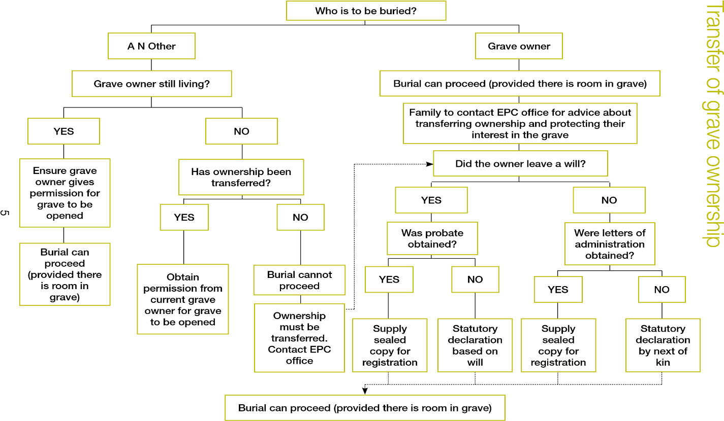
Family to contact LMPC office for advice about transferring ownership and protecting their interest in the grave.

Forms of transferring deeds ownership

Form of Assignment
Used by a living owner to transfer or change the ownership of the exclusive Rights of Burial i.e. to transfer to new owner or add an additional owner.

Grant of Probate
Granted to the executor/s of a Last Will and Testament once a document has been proven in Court. To be legally acceptable we can only accept sight of a “SEALED” Grant; i.e. it must bear the embossed seal of the court.

Letters of Administration
When a deceased person dies intestate then the next of kin can apply to the Courts to be made Administrator of the estate. An Administrator receives the same powers to administer the estate of the deceased as an executor.

Form of Assent
Used to transfer ownership from an executor or administrator after ownership has been transferred into their name by production of Probate or Letters of Administration.

Statutory Declaration
Used to transfer ownership from a deceased owner when no official documents have been issued. Declarations can be either based on a Will that did not go to probate, claiming ownership by the executor or by the Next of Kin if the deceased left no will.

Form of Renunciation
Grave ownership is limited to two people. So in the event that ownership is claimed by more than two people, the parties involved will need to agree amongst themselves who will renounce their claim using the Renunciation Form, which should be submitted to the Clerk together with a Statutory Declaration.

Certificates
All certificates supplied with transfer applications must be originals or certified copies.
(NB Birth certificates supplied for identification in a Deed Transfer must be a full birth certificate and not a short birth certificate.)

The National Archives
You will need to know the full names, date and place of death. If this is not known, you can search the index of deaths from 1837 until the present day, at the National Archives at Kew, Richmond, Surrey TW9 4DU. Telephone 020 8876 3444 or you could visit their website http://www.nationalarchives. gov.uk for useful information. From 1984 you search by a year and then alphabetically by surname. Prior to 1984 the search is by quarters of each year.

The Register Office
If the death was within the last 18 months, you can ask for a copy death certificate from the Register Office for the area in which the death occurred.
You can get a copy certificate from 1836 to the present day from The General Register Office (G.R.O). Copy death certificates can also be ordered online http://www.gro.gov.uk/gro/content/certificates. Further useful information can be found at www.direct.gov.uk

The National Archives
If you need to find out if a Will was made, you can search the index to all
Wills at the National Archives at Kew http://www.nationalarchives.gov.uk Their index is from 1858 to 1943 on microfiche. You could visit their website for help and information.

The Probate Service
Information on how to obtain a copy of a will or probate can be found online at https://www.gov.uk/search-will-probate. The search itself can be done online or by post using the form PA15.

